- Title and Author.
Assignment 1
羅瑋翔
110704008
xianglo9121.mg10@nycu.edu.tw
- Statement of the problem.
To let the users to input the date as the format yyyy/mm/dd and generate MonthName dd, yyyy as output. For example, September 15, 2023.
And there are 3 additional functions provided from the three code.
- DayOfWeek : Input yyyy/mm/dd (string), and return day of the week as the format MonthName dd, yyyy is Day. For example, input 2023/09/15 .The output will be September 15, 2023 is Friday.
- DateSub : Input yyyy/mm/dd (string) – YYYY/MM/DD (string) and return number of days from date1 to date2. For example, input 2019/09/20 – 2018/09/20. The output will be 365 days from September 20, 2019 to September 20, 2018.
- DateAdd : Input yyyy/mm/dd (string) + n(integer, whether positive or negative is allowed), and return the date which is n days after the input date. For example, input 2019/9/20 + 365. The output will be 365dyas after September 20, 2019 is September 19, 2020.
- Main results.
(a)DateOfWeek
//I create a class named as TheDate, and there are constructor, accessor
//functions, mutator functions in the public part, member variables in the
//private part. The important parts are (1) void isLeapYear(int year) is used to
//check whether the year is leap year. To help isLegal() function to check the
//input format is right or not. (2) void isLegal(), this function is used to check
//whether the input is right or not. If the date does not exist, WRONG FORMAT
//will be printed on the screen. (3) string weekday() in this part I use the Zeller
//formula to return the day of the week, such as Monday, Tuesday … (4) string
//monthItoS(int month) is used to transform the month form integer to string.
//In the main function, I allowed the users to input the date and first I saved the
//input with the datatype string since there are ‘/’ in the input. Then I use
//getline function to separate the year, month and day and saved them in a
//string array. Followed by is Changning the datatype from string to integer with
//the stoi() function. The last part is to construct the class and print the result.
#include<iostream>
#include<cstring>
#include<sstream>
#include<cmath>
#include<cstdlib>
using namespace std;

//these array are used in many part of the code
const int LEAPY[12] = {31, 29, 31, 30, 31, 30, 31, 31, 30, 31, 30, 31};
const int NOTLEAPY[12] = {31, 28, 31, 30, 31, 30, 31, 31, 30, 31, 30, 31};

class TheDate{
public:
//constructor
TheDate();
TheDate(int, int, int);
int getYear();
int getMonth();
int getDay();
void setYear(int newYear);
void setMonth(int newMonth);
void setDay(int newDay);
bool isLeapYear(int year);
void isLegal();
string weekDay();
string monthItoS(int month);
private:
int year;
int month;
int day;
int w;
};

int main(){
TheDate date_1;
string date_str[3];
string date_cin;

int date_int[3];
int i = 0;
cout << "Enter the date (e.g: yyyy/mm/dd) : ";
cin >> date_cin;
stringstream ss;
ss << date_cin;
while (i <= 2){
getline(ss, date_str[i], '/');
date_int[i] = stoi(date_str[i]);
i++;
}

date_1.setYear(date_int[0]);
date_1.setMonth(date_int[1]);
date_1.setDay(date_int[2]);
date_1.isLegal();
cout << date_1.monthItoS(date_int[1]) << " " << date_str[2] << ", " << date_str[0] << " is " << date_1.weekDay() <<"." << endl;

system("PAUSE");
return 0;
}

TheDate::TheDate():year(1), month(1), day(1)
{}

TheDate::TheDate(int theYear, int theMonth, int theDay):year(theYear), month(theMonth), day(theDay)
{}

int TheDate::getYear()
{
return year;
}

int TheDate::getMonth()
{
return month;
}

int TheDate::getDay()
{
return day;
}

void TheDate::setYear(int newYear)
{
year = newYear;
}

void TheDate::setMonth(int newMonth)
{
month = newMonth;
}

void TheDate::setDay(int newDay)
{
day = newDay;
}

bool TheDate::isLeapYear(int year)
{
if(((year % 4 == 0) && (year % 100 != 0)) || (year % 400 == 0))
return true;
return false;
}

void TheDate::isLegal()
{
if(year <= 0 || month <= 0 || month >= 12 || day <= 0){
cout << "WRONG FORMAT!" << endl;
exit(1);
}
if(isLeapYear(year)){
if(LEAPY[month - 1] >= day)
return;
}
else{
if(NOTLEAPY[month - 1] >= day)
return;
}
cout << "WRONG FORMAT!" << endl;
exit(1);
}

string TheDate::weekDay(){
int w = 0;
w = (day + 2 * month + 3 * (month + 1) / 5 + year + year / 4 - year / 100 + year / 400) % 7;//Zeller function used to find the day of the week
string tmp[7] = {"Monday", "Tuesday", "Wednesday", "Thursday", "Friday", "Saturday", "Sunday"};//claim an array to the w find the according part and return it.
return tmp[w];
}
//find the according part of the month with array
string TheDate::monthItoS(int month){
string tmp[12] = {"January", "February", "March", "April", "May", "June", "July", "August", "September", "Octobor", "November", "December"};
return tmp[month - 1];
}
(b) DateSub
//I added (1) int sumOfdays() in the class, this function is used to transform the
//date from yyyy/mm/dd to the sum of days from 1/1/1 A.D. Since the two date
//transform to the sum of days, we can easily find the difference of the two
//date. And the main function allows the users to input. And call the mutator
//function in the class, then manifest the result on the screen. The remaining
//part are quite the same as the above code.
#include<iostream>
#include<cstring>
#include<sstream>
#include<cmath>
#include<cstdlib>
using namespace std;

const int LEAPY[12] = {31, 29, 31, 30, 31, 30, 31, 31, 30, 31, 30, 31};
const int NOTLEAPY[12] = {31, 28, 31, 30, 31, 30, 31, 31, 30, 31, 30, 31};

class TheDate{
public:
TheDate();
TheDate(int, int, int);
int getYear();
int getMonth();
int getDay();
void setYear(int newYear);
void setMonth(int newMonth);
void setDay(int newDay);
bool isLeapYear(int year);
void isLegal();
string weekDay();
string monthItoS(int month);
int sumOfdays();
private:
int year;
int month;
int day;
int w;
};

int main(){
TheDate date_1, date_2;
string date_str1[3], date_str2[3];
string date_cin1, date_cin2;
char sub;
int date_int1[3], date_int2[3];
int i = 0;
cout << "Enter the date 1 and date 2 to substract (e.g: yyyy/mm/dd - YYYY/MM/DD) : ";
cin >> date_cin1 >> sub >> date_cin2;
stringstream ss1, ss2;
ss1 << date_cin1;
ss2 << date_cin2;
while (i <= 2){
getline(ss1, date_str1[i], '/');
date_int1[i] = stoi(date_str1[i]);
getline(ss2, date_str2[i], '/');
date_int2[i] = stoi(date_str2[i]);
i++;
}

date_1.setYear(date_int1[0]);
date_1.setMonth(date_int1[1]);
date_1.setDay(date_int1[2]);
date_1.isLegal();
date_2.setYear(date_int2[0]);
date_2.setMonth(date_int2[1]);
date_2.setDay(date_int2[2]);
date_2.isLegal();
cout << abs(date_1.sumOfdays() - date_2.sumOfdays()) << " days from " << date_1.monthItoS(date_1.getMonth()) << " " << date_1.getDay() << ", " << date_1.getYear()
<< " is " << date_2.monthItoS(date_2.getMonth()) << " " << date_2.getDay() << ", " << date_2.getYear() << ".\n";

system("PAUSE");
return 0;
}

TheDate::TheDate():year(1), month(1), day(1)
{}

TheDate::TheDate(int theYear, int theMonth, int theDay):year(theYear), month(theMonth), day(theDay)
{}

int TheDate::getYear()
{
return year;
}

int TheDate::getMonth()
{
return month;
}

int TheDate::getDay()
{
return day;
}

void TheDate::setYear(int newYear)
{
year = newYear;
}

void TheDate::setMonth(int newMonth)
{
month = newMonth;
}

void TheDate::setDay(int newDay)
{
day = newDay;
}

bool TheDate::isLeapYear(int year)
{
if(((year % 4 == 0) && (year % 100 != 0)) || (year % 400 == 0))
return true;
return false;
}

void TheDate::isLegal()
{
if(year <= 0 || month <= 0 || month >= 12 || day <= 0){
cout << "WRONG FORMAT!" << endl;
exit(1);
}
if(isLeapYear(year)){
if(LEAPY[month - 1] >= day)
return;
}
else{
if(NOTLEAPY[month - 1] >= day)
return;
}
cout << "WRONG FORMAT!" << endl;
exit(1);
}

string TheDate::weekDay(){
int w = 0;
w = (day + 2 * month + 3 * (month + 1) / 5 + year + year / 4 - year / 100 + year / 400) % 7;
string tmp[7] = {"Monday", "Tuesday", "Wednesday", "Thursday", "Friday", "Saturday", "Sunday"};
return tmp[w];
}

string TheDate::monthItoS(int month){
string tmp[12] = {"January", "February", "March", "April", "May", "June", "July", "August", "September", "Octobor", "November", "December"};
return tmp[month - 1];
}

int TheDate::sumOfdays(){
int sum = 0;
if(year > 1){
for(int i = 1; i < year; i++){
if(isLeapYear(i))
sum += 366;
else
sum += 365;
}
}
if(month > 1){
for(int i = 0; i < month - 1; i++){
if(isLeapYear(year))
sum += LEAPY[i];
else
sum += NOTLEAPY[i];
}
}
sum += day;

return sum;
}
(c)DateAdd
//In this part I added void dateAftAdd(int), this function is used to calculate the
//new date after date after n days. First I use the sum of days to transform the
//date, then add the input n days. And send the sum of days + n days to the
//dateAftAdd function to get the new Date as the format : yyyy/mm/dd.
#include<iostream>
#include<cstring>
#include<sstream>
#include<cmath>
#include<cstdlib>
using namespace std;

const int LEAPY[12] = {31, 29, 31, 30, 31, 30, 31, 31, 30, 31, 30, 31};
const int NOTLEAPY[12] = {31, 28, 31, 30, 31, 30, 31, 31, 30, 31, 30, 31};

class TheDate{
public:
TheDate();
TheDate(int, int, int);
int getYear();
int getMonth();
int getDay();
void setYear(int newYear);
void setMonth(int newMonth);
void setDay(int newDay);
bool isLeapYear(int year);
void isLegal();
string weekDay();
string monthItoS(int month);
int sumOfdays();
void dateAftAdd(int);
private:
int year;
int month;
int day;
int w;
};

int main(){
TheDate date_1;
string date_str[3];
string date_cin;
string month;
char add;
int days;
int date_int[3];
int i = 0;
cout << "Enter the date and x days to add (e.g: yyyy/mm/dd + x) : ";
cin >> date_cin >> add >> days;
stringstream ss;
ss << date_cin;
while (i <= 2){
getline(ss, date_str[i], '/');
date_int[i] = stoi(date_str[i]);
i++;
}

date_1.setYear(date_int[0]);
date_1.setMonth(date_int[1]);
date_1.setDay(date_int[2]);
date_1.isLegal();
month = date_1.monthItoS(date_1.getMonth());
date_1.dateAftAdd(date_1.sumOfdays() + days);
cout << days << " days after " << month << " " << date_str[2] << ", " << date_str[0] << " is "
<< date_1.monthItoS(date_1.getMonth()) << " " << date_1.getDay() << ", " << date_1.getYear() << ".\n";

system("PAUSE");
return 0;
}

TheDate::TheDate():year(1), month(1), day(1)
{}

TheDate::TheDate(int theYear, int theMonth, int theDay):year(theYear), month(theMonth), day(theDay)
{}

int TheDate::getYear()
{
return year;
}

int TheDate::getMonth()
{
return month;
}

int TheDate::getDay()
{
return day;
}

void TheDate::setYear(int newYear)
{
year = newYear;
}

void TheDate::setMonth(int newMonth)
{
month = newMonth;
}

void TheDate::setDay(int newDay)
{
day = newDay;
}

bool TheDate::isLeapYear(int year)
{
if(((year % 4 == 0) && (year % 100 != 0)) || (year % 400 == 0))
return true;
return false;
}

void TheDate::isLegal()
{
if(year <= 0 || month <= 0 || month >= 12 || day <= 0){
cout << "WRONG FORMAT!" << endl;
exit(1);
}
if(isLeapYear(year)){
if(LEAPY[month - 1] >= day)
return;
}
else{
if(NOTLEAPY[month - 1] >= day)
return;
}
cout << "WRONG FORMAT!" << endl;
exit(1);
}

string TheDate::weekDay(){
int w = 0;
w = (day + 2 * month + 3 * (month + 1) / 5 + year + year / 4 - year / 100 + year / 400) % 7;
string tmp[7] = {"Monday", "Tuesday", "Wednesday", "Thursday", "Friday", "Saturday", "Sunday"};
return tmp[w];
}

string TheDate::monthItoS(int month){
string tmp[12] = {"January", "February", "March", "April", "May", "June", "July", "August", "September", "Octobor", "November", "December"};
return tmp[month - 1];
}

int TheDate::sumOfdays(){
int sum = 0;
if(year > 1){
for(int i = 1; i < year; i++){
if(isLeapYear(i))
sum += 366;
else
sum += 365;
}
}
if(month > 1){
for(int i = 0; i < month - 1; i++){
if(isLeapYear(year))
sum += LEAPY[i];
else
sum += NOTLEAPY[i];
}
}
sum += day;

return sum;
}

void TheDate::dateAftAdd(int sum)
{
//count how many year need to be added to the year
int countYear = 1;
while((sum >= 366 && isLeapYear(countYear)) || (sum >= 365 && !isLeapYear(countYear))){
if(isLeapYear(countYear))
sum -= 366;
else
sum -= 365;
countYear++;
}
year = countYear;

//count how many month need to be added to the month
int countMonth = 0;
if(isLeapYear(year)){
while(sum >= LEAPY[countMonth]){
sum -= LEAPY[countMonth];
countMonth++;
}
month = countMonth + 1;
}
else{
while(sum >= NOTLEAPY[countMonth]){
sum -= NOTLEAPY[countMonth];
countMonth++;
}
month = countMonth + 1;
}
day = sum;
}
- The data structure I used in this assignment is “class”. It is easy for us to use the code again, if we were constructing another element. And make hide the detail in the class to make the main function looks simple and easily reading.
Result of (a) DayOfWeek.
Test data :
- 2023/09/19
- 2000/02/29
- 1900/02/29
- 2000/01/32
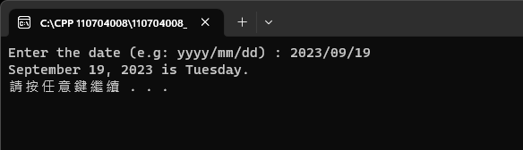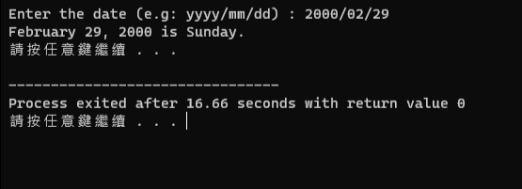
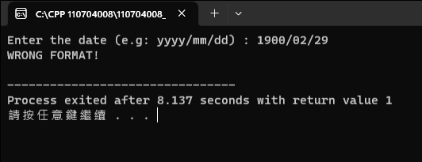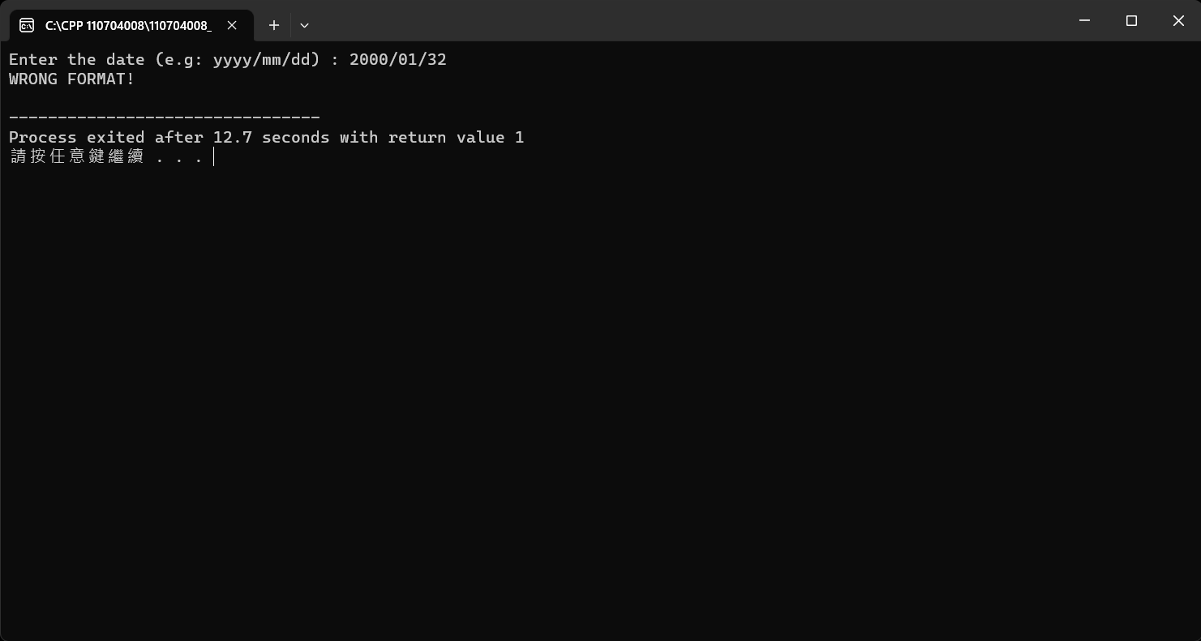

Result of (b) DaySub.
Test data :
- 2023/09/19 – 2023/09/10
- 2023/09/19 – 2023/08/15
- 2023/09/19 – 2022/09/15
- 2020/01/11 – 2022/01/15
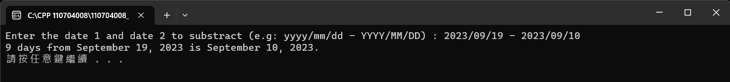
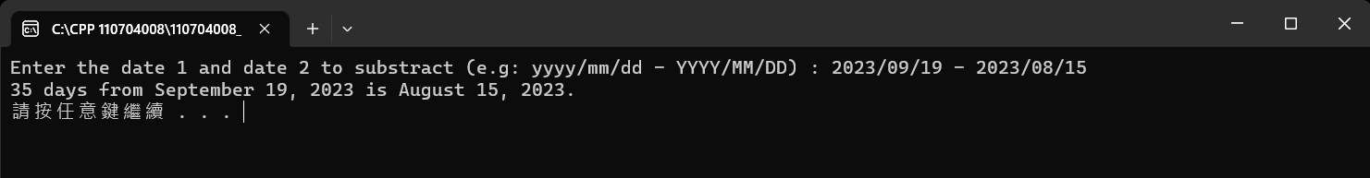
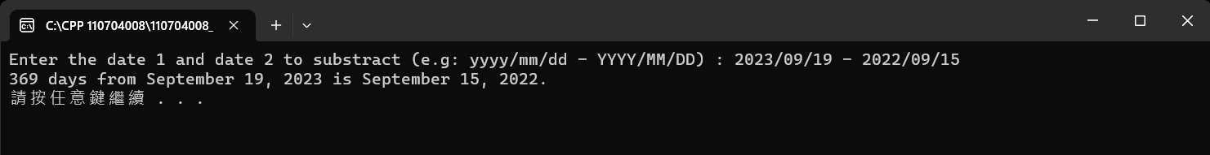
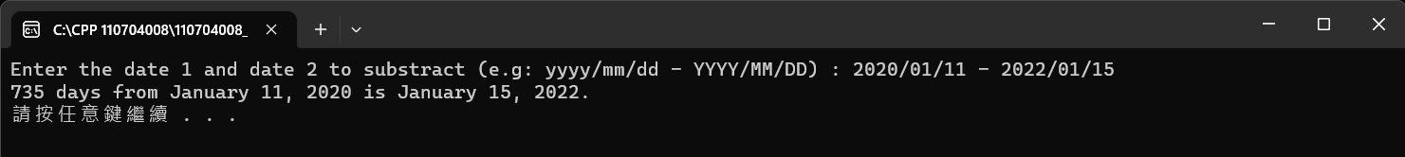

Result of (c) DayAdd.
Test data :
- 2023/09/19 + 5
- 2023/09/19 + 32
- 2023/09/19 + 395
- 2023/09/19 + -62
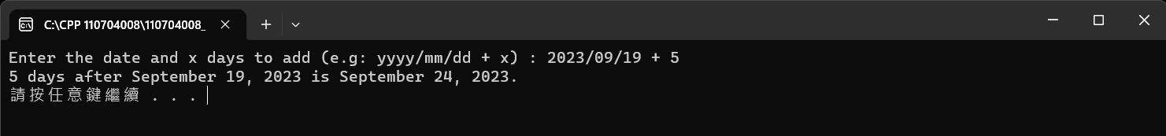
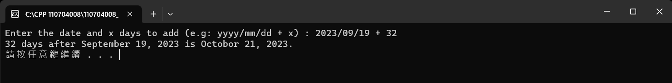
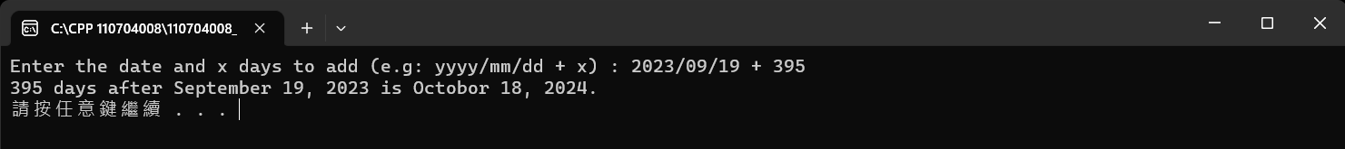
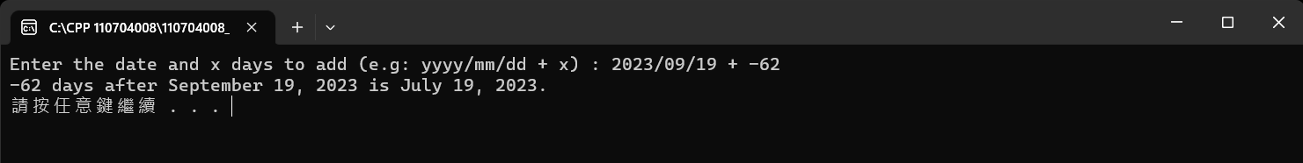

- Conclusions.
During this assignment, I find that if we are using the same code, it is convenient for us to use data structure, since the class done, we can use it many times to construct a lot of object. But I think this assignment is not a good example to use data structure. Because the data we need to handle is not a lot.

